Eritrea

## Political Stability Estimate Data

The data set shows the political stability estimate of the country each year.

## # A tibble: 19 x 5  
## country iso3c date stability stabilityCategory4   
## <chr> <chr> <dbl> <dbl> <chr>   
## 1 Eritrea ERI 1996 -0.936 moderately unstable  
## 2 Eritrea ERI 1998 -0.969 moderately unstable  
## 3 Eritrea ERI 2000 -0.769 moderately unstable  
## 4 Eritrea ERI 2002 -0.267 moderately unstable  
## 5 Eritrea ERI 2003 -0.719 moderately unstable  
## 6 Eritrea ERI 2004 -0.639 moderately unstable  
## 7 Eritrea ERI 2005 -0.795 moderately unstable  
## 8 Eritrea ERI 2006 -0.900 moderately unstable  
## 9 Eritrea ERI 2007 -1.05 highly unstable   
## 10 Eritrea ERI 2008 -0.711 moderately unstable  
## 11 Eritrea ERI 2009 -0.681 moderately unstable  
## 12 Eritrea ERI 2010 -0.876 moderately unstable  
## 13 Eritrea ERI 2011 -0.766 moderately unstable  
## 14 Eritrea ERI 2012 -0.702 moderately unstable  
## 15 Eritrea ERI 2013 -0.772 moderately unstable  
## 16 Eritrea ERI 2014 -0.806 moderately unstable  
## 17 Eritrea ERI 2015 -0.877 moderately unstable  
## 18 Eritrea ERI 2016 -0.657 moderately unstable  
## 19 Eritrea ERI 2017 -0.656 moderately unstable

## Political Stability Estimate Plot

The plot shows the trends of stabilization and destabilization for the each country.

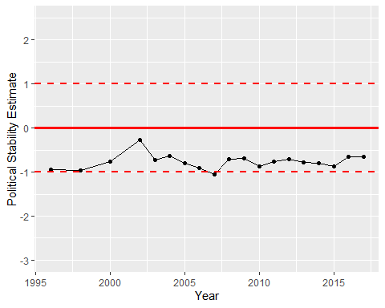

Political Stability Trend